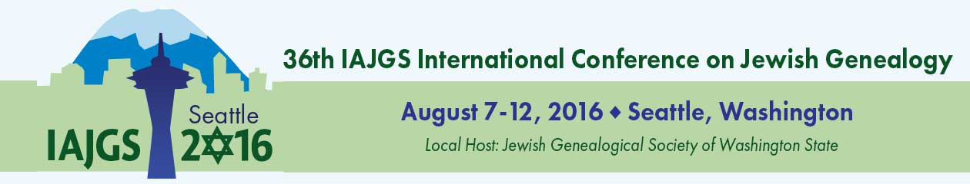

APPLICATION FOR

IAJGS 2016 SEATTLE CONFERENCE EVENT:

SHARE Fair

We welcome participation by non-profit organizations involved in or supporting Jewish genealogy in a free “SHARE Fair” which will be held as part of the 36th IAJGS International Conference on Jewish Genealogy. This includes Jewish Genealogical Societies, Jewish Historical Societies, Special Interest Groups, Birds of a Feather groups, Libraries, Archives and other non-profit organizations.

Annual conferences on Jewish Genealogy have been held every summer since 1981. The conference will include a full program of presentations and workshops, Breakfasts with the Experts, Special Interest Group luncheons, a Gala Banquet and more. One of the focus areas will be the Sephardic experience in America, in all of its varied aspects.
The Conference will open on Sunday, August 7, 2016 and run through Friday, August 12, 2016. The SHARE Fair will take place from 1:30 pm to 5:00 pm on August 7 at the Sheraton Seattle Hotel in Seattle, Washington. A large area has been set aside for organizations to share information about themselves and the services they offer. This is a terrific way to let interested people know about your organization. The SHARE Fair is a non-commercial event. While you may sign up new members, no other selling of products or services is allowed.

Participating organizations will be provided with one or two 6’ draped tables and two chairs per table. The organization may display and give away materials relevant to family history or research. Arrangements should be made directly with the hotel for shipping, delivery, receipt and storage of any items to be displayed. Note that the hotel does not allow taping or pinning anything to their walls. Organizations should plan to set up their tables one hour before the SHARE Fair starts and remove all materials and vacate the hall by 5:30 pm. Neither electrical power nor free Internet connectivity will be provided. Table locations will be assigned.

If your organization wishes to participate in the SHARE Fair, please submit your application by February 15, 2016 and send it as an email attachment to sharefare@iajgs2016.org. If you have questions, please send them to this address as well. Although we anticipate being able to accommodate all appropriate organizations that apply by this deadline, space is limited and will be provided based on timing of completed acceptable applications.

Organizations may have up to four individuals represent them at the SHARE Fair. The organization must provide the Conference with the names of its representatives by July 1, 2016. If representatives are not Conference Registrants, they must check in at the Registration Desk and will be provided a special badge, which will permit entry only to the SHARE Fair.

Alternatively, if your organization is commercial, wishes to sell items or simply maintain a display throughout the conference (from Sunday through Thursday), it may contract for a location in the Exhibitor Hall. Information on becoming an Exhibitor will be available shortly.

36th IAJGS International Conference on Jewish Genealogy
SHARE Fair Application

Name of Organization: ________________________________________________________________________

Primary Purpose of Organization: ________________________________________________________________________________________

Participation Rules and Limitations
- SHARE Fair participants must set up their displays on Sunday, August 7, 2016 between noon and 1:30 pm. They must break down and remove their displays between 5:00pm and 5:30pm.
- Organization takes responsibility for all materials used during the SHARE Fair and any related expenses.
- Organization agrees to staff their table(s) throughout the SHARE Fair with one or two knowledgeable people per table who can answer questions about their organization.
- Organization will provide the Conference with the names of those who will represent it at the SHARE Fair by July 1, 2016. Individuals who are not Conference Registrants will only have access to the SHARE Fair.
- Organization understands that this is a non-commercial event and will refrain from any selling. They may sign up new members if a membership organization.
- Organization commits to providing displays and information related to Jewish genealogy and research. It further affirms that their displays will not be controversial or offensive to conference registrants.
- Organizations are responsible for the safety of any articles they bring to the SHARE Fair.
- Conference may deny applications or later terminate them at its sole discretion. If terminated during the SHARE Fair, the Organization is to promptly remove its display and leave the premises.

Special requests (e.g. to be co-located near another organization):
____________________________________________________________________________________________________________________________________
____________________________________________________________________________________________________________________________________

By placing an “X” in the box to the left, you are affirming that
1) This is a non-profit organization involved in or supporting Jewish genealogy
2) This organization agrees to participate in the SHARE Fair and adhere to its rules and limitations
3) You are authorized to submit this application on behalf of your Organization

4) You will serve as the primary contact or will provide the contact information for that person
Questions? Please contact us at sharefare@iajgs2016.org.

(Sign electronically or by hand. Some browsers may not permit you to sign a PDF electronically. If so,
please print, sign and scan.)

__________________________________________________________ ____________________________________
AUTHORIZED SIGNATURE Date

Name: _________________________________________________________ Title: _______________________________________________________
Mailing Address: _____________________________________________________________________________________________________________
Primary Phone: ________________________________________________Alternate phone ___________________________________________
Email Address: _______________________________________________ Website URL: _____________________________________________

Complete the form on line and save it (or print and scan it). Then, attach it to an email to sharefare@iajgs2016.org.

